This Career Planning Worksheet is designed to assist Rice employees in a self-directed assessment, exploratory and planning process.

Complete the following three sections, choosing from an option of assessments, questions and exercises to begin the process.

Career Assessment

No Fee

My Next Move https://www.mynextmove.org/explore/ip

Holland http://www.truity.com/test/holland-code-career-test

16 Personalities https://www.16personalities.com/free-personality-test

Fee-based (Contact us at Melinda.English@Rice.edu)

MBTI® Career Report ($20.00) - sample report available upon request

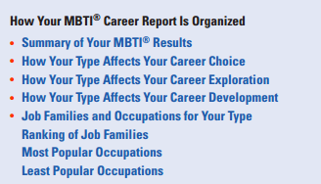

Strong Interest Inventory Assessment ($20.00) - sample report available upon request

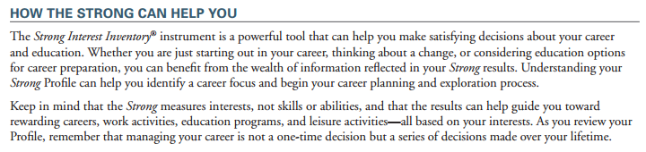

Values Identification

It is important to take the time to identify your values, specifically how they align with your work. Using 24 character strengths, the profile will identify the character strengths that come most naturally to you (your unique report).

FREE ASSESSMENT

Beliefs
Like values, our beliefs motivate us and impact our results. We collect our beliefs, usually subconsciously, from our friends, family, society and from our experiences.

Explore some of your beliefs by completing the following sentences.

I always…
I never…
I can’t…
We are…
I must…
My work is…
My time is…
My team is…
There are times when I…
Life is all about…
I love…
Success is…
Teamwork is…
Life is…
Family is…
Love is…
I am…
I can…
List any old beliefs are you going (would like to) to change.

List any new beliefs are you going to develop

